Safeguarding and Child Protection Policy
This policy is directed to meet the particular needs of the children at The Loddon School
Policy Statement
At The Loddon School, we are committed to safeguarding children and young people and we expect everyone who works in our school to share this commitment.
A culture in which all adults take child welfare and child safety matters seriously is crucial to The Loddon School.
This policy seeks to provide staff and trustees with a clear framework and guidance about how we will ensure the safety of children at our school.
We will always act in the best interest of the child.

At The Loddon School, the Designated Safeguarding Lead is Tim Clark, Vice Principal - Care. In his absence the Designated Deputies are Kelly Simpson, Alison Beaven and Joanna Emerson.
The trustees designated for safeguarding are Joy Wake & Marion Cornick. Any concerns may be raised to any of the above persons or to the Hampshire Safeguarding Children’s Partnership (HSCP) or LADO with whom The Loddon School have a close working relationship.
Parents are made aware of this policy during the admissions process. They can access this information on the website or receive a printed copy upon request.

Purpose
The above introduction to the school outlines the difficulties experienced by the children and young people and justifies the consequent need for intensive staffing. The potential vulnerability of the children is recognised in this policy, the aim of which is to ensure that all children and young people are safeguarded.
The Loddon School fully recognises its responsibility to safeguard and promote the welfare of children and young people at our school. The purpose of this policy is to provide staff, volunteers and trustees with the guidance they need in order to keep children and young people safe and secure in our school and to inform parents and guardians of our strategies for safeguarding their children and young people whilst they are in our care.
We recognise that children and young people have a right to feel secure and cannot learn effectively unless they do so. Children can be harmed either by direct acts (by parents, carers and other people) or failure to provide proper care or both. Children may suffer abuse (neglect, emotional, physical, financial, sexual or other forms of abuse) or a combination of such types of abuse. All children and young people have a right to be protected from harm. This policy includes guidance in relation to dealing with allegations involving staff in the home, e-safety and self-injurious behaviour.

Aims
These procedures apply to all staff (those who work directly with the children and all those who do not), trustees and visitors to the school. The aim of our procedures is to prevent children and young people from being harmed and to safeguard and promote the welfare of children and young people at this school in the following ways:-
- Raise awareness of child protection and safeguarding roles and responsibilities with staff, trustees and visitors.
- Develop, implement and review procedures in our school that enable all staff to identify and report cases, or suspected cases, of abuse.
- Support children and young people who have been abused in accordance with their agreed child protection plan.
- Ensure the practice of safer recruitment in checking and recording the suitability of staff to work with children and young people.
- Establish a safe environment in which children and young people can live, learn and develop.
- Ensure that allegations or concerns against staff are dealt with in accordance with Department for Education (DfE) and Hampshire Safeguarding Children’s Partnership guidelines.

The Loddon School context
The Loddon School is both an independent special school and a children’s home but, throughout this policy, will be referred to as The Loddon School. The Loddon School educates and cares for children and a small number of young adults; this policy refers to all young people accommodated at The Loddon School.
The Loddon School admits children and young people who engage in extreme and high risk challenging behaviour, known at Loddon as restrictive behaviour (behaviour that restricts the child’s opportunities to learn or develop), and who experience severe and complex learning difficulties and usually autism.
Most children and young people will have been excluded from their local special school or will have been previously separated from the rest of their class or assigned extra staff. Children will typically have used their restrictive behaviours to avoid class-based activities and will find formal classroom teaching aversive. They are often resistant to perceived demands; this limits their ability to engage in learning, social and wellbeing activities. For many children and young people residential respite provision will have broken down and the family living situation will most often have become too difficult to sustain.
Children are assessed against the school’s “Essential Criteria for Admission” which includes a range of restrictive behaviours. To be considered for admission to the school, children and young people will have been seen to use a number of these behaviours to get their needs met.
All children and young people have a Statement of SEN or an Education, Health & Care Plan. Many children have diagnoses of autism, epilepsy, ADHD or other health needs. All children and young people need high levels of adult support both day and night to keep them safe to minimise the risks to both themselves and others.
Most children and young people are non -verbal and on admission have few strategies for making their needs known beyond using a range of restrictive behaviours. Often children and young people need time to process information.
Many children and young people experience anxiety that manifests itself in a variety of behaviours such as aggression, flopping to the ground, running off, perceived non-cooperation, making loud noises, inappropriate removal of clothing, incontinence, or sleep difficulties.
The children and young people have difficulties making sense of their world and have little awareness of events beyond their own experiences. They typically have few social skills. They have difficulty in understanding concepts and in responding appropriately to the consequences of their behaviours.

We must remember that the five statutory principles of the Mental Capacity Act (2005) apply to young people aged 16 and over:
- A person must be assumed to have capacity unless it is established that they lack capacity.
- A person is not to be treated as unable to make a decision unless all practicable steps to help him to do so have been taken without success.
- A person is not to be treated as unable to make a decision merely because he makes an unwise decision.
- An act done, or decision made, under this Act for or on behalf of a person who lacks capacity must be done, or made, in his best interests.
- Before the act is done, or the decision is made, regard must be had to whether the purpose for which it is needed can be as effectively achieved in a way that is less restrictive of the person’s rights and freedom of action.

For the avoidance of doubt, they are unlikely to have the capacity to give informed consent of most significant decisions in relation to their care, health, education, living arrangements or finances; of course, however, this cannot be assumed.
In most cases, a young person’s parents count as their “best interests” consultees if they lack capacity, and no step can be taken in relation to their wellbeing or treatment without consulting those persons.
At The Loddon School children are encouraged to keep themselves safe. Several aspects of the PLLUSS curriculum focus on improving the child’s ability to stay safe.
Whilst the school will work openly with parents as far as possible, the school reserves the right to contact Children’s Social Care, Hampshire Safeguarding Children’s Partnership or the Police, without notifying parents if this is believed by the school Designated Safeguarding Lead or Deputy to be in the child’s best interests.

The Loddon School’s responsibilities in Keeping Children Safe
The Loddon School recognises that because of their day-to-day contact with children and young people, school staff are well placed to observe the outward signs of abuse.
N.B. Interactions between young people over the age of 16 may not necessarily be criminal or indicative of abuse when due regard is given to the developing capacity of the individual and their ability to give informed consent.
The school will therefore:
- Recognise the specific vulnerabilities of the Loddon children and young people.
- Establish and maintain an environment where children and young people feel secure, are encouraged to communicate and are listened to.
- Ensure children and young people know that there are adults in the school whom they can approach if they are worried about any problems. The voice of the child is paramount & staff should respond to any concerns or allegations raised.
- Treat all disclosures with the strictest confidence. Care should be taken not to unlawfully breach the young person’s right to confidentiality in so far as they may have limited capacity to express their wishes about this. However, staff should never promise confidentiality of a disclosure of abuse.
- Follow the procedures set out by the Hampshire Safeguarding Children’s Partnership and take account of guidance issued by the DfE.
- Ensure that there is a senior designated person/Designated Safeguarding Lead (DSL) supported by a number of designated deputies.
- Operate a policy of careful selection of employees (Safer Recruitment). Three references are taken up, one prior to interview and at least two further ones. A prospective employee is required to work alongside a Team Coordinator or Mentor for a day before a decision on employment is made (at no point are they left unsupervised with the children and young people).
- Take up DBS & Children’s Barred List checks and references on all employees prior to employment.
- Operate a three-month probationary period for all new staff.
- Have a high staff ratio thus minimising the need for a member of staff to be alone with a child.
- Provide intensive staff training in safeguarding.
- This takes the following forms:
  - one month’s mentoring/shadowing
  - 5 full days of orientation and induction training
  - regular supervision and annual appraisal
  - formal workshops
  - refresher training at least every year
  - external courses
- Provide training in the Loddon proactive approaches; the PLLUSS (Personalised Learning for Life Using Supportive Strategies) curriculum and PROACT-SCIPr-UK®, a package of staff training which is accredited within the BILD Code of Practice. Physical interventions taught as part of the PROACT-SCIPr-UK® curriculum are the only ones permitted. [See also Challenging Behaviour Policy]
- Provide training in the principles of Mental Capacity Act (2005) and Deprivation of Liberty Safeguards
- Facilitate visits from the health professionals from various community health teams and the school G.P.
- Facilitate frequent visits from each child's own local authority social worker.
- Ensure the child’s social worker is informed at least monthly of any physical or restrictive interventions that have had to be used with the child as well as informing them immediately of any harm they may have come to during an incident or at any other time.
- Have "friendly" police visits.

Monitoring
The Leadership Team monitor all incident reports weekly and identify where further or different action may need to be taken to safeguard a particular individual. This will include where issues or concerns need to be notified to other agencies (e.g., local authorities, Hampshire Safeguarding Children’s Partnership, Ofsted, Charities Commission). Where actions need to be taken above and beyond the child’s current written Risk Assessment and Support Guidelines, the Local Authority and parents will be notified immediately and then the guidelines changed with their agreement.

Likewise, practices will be reviewed monthly with restrictions reduced as soon as safe to do so. Every child’s Individual Education, Health and Care Plan will be aimed at reducing restrictive behaviours and the need for restrictive practices.

Local authorities (social workers or placement officers) are kept informed of each child’s wellbeing. This includes information about critical incidents and potentially restrictive practices. When requested, incident reports are sent at least monthly via email by the Positive Behaviour Support Manager.

The Children’s Homes (England) Regulations 2015 do not prevent a child being deprived of their liberty, where that deprivation is authorized in accordance with a court order. The Loddon School and DSL recognises that in exceptional circumstances where there might be concern as to the proportionality of restrictive measures believed to be being taken in the child’s best interests, it has an obligation to alert the local authority that is commissioning the care, as well as the Local Children’s Safeguarding Board, in relation to the statutory authorities considering whether an application needs to be made to the Court of Protection.

Staff responsibilities
- To understand and follow this policy.
- To attend all Safeguarding, MCA and DoLS training.
- To prevent harm to the children and young people wherever possible.
- To be aware of the signs and symptoms of abuse.
- To know the reporting procedures if any abuse is suspected, witnessed or disclosed.
- To immediately report any concerns about a child’s safety or welfare to the DSL or DSL deputies.
- Maintain an attitude of ‘It could happen here’ in relation to safeguarding and child protection concerns.
- If the disclosure is an allegation against a member of staff they will follow the allegations procedures attached to this policy.
- Direct care staff to monitor marks (or absence of) on a child’s body during personal care routines and complete body maps for children and young people at least on a weekly basis.
- Understand the content of Part One and Annex A of Keeping Children Safe in Education – use this link to see the most up to date copy.
- To make it clear to the DSL or a DSL deputy if they do not understand any of the information contained in Part One and Annex A of Keeping Children Safe in Education (KCSIE).
- To understand the risks involved with Loddon children and young people using the internet and to supervise them accordingly. [See also e-safety policy].
- To follow the training given regarding positive interaction and physical interventions using only PROACT- SCIPr –UK®.
- To adhere to the policy for taking children and young people off school premises which includes a risk assessment for every outing.
- To treat all safeguarding related information as confidential, and only discuss safeguarding matters with others who need the information in pursuance of maintaining and protecting the safety and welfare of a child or group of children.

Designated Safeguarding Lead & Deputies responsibilities
In this school the Designated Safeguarding Lead is Tim Clark – Vice Principal - Care. In his absence the Designated Deputies are Kelly Simpson, Alison Beaven and Joanna Emerson.
The DSL and deputies will:
- Foster a culture in which all staff place great importance on child safety and welfare matters, have high aspirations for Loddon children, and place the children’s best interests as paramount in their thoughts and actions.
- Ensure that the Trustees understand their responsibilities under s.175 of the Education Act 2002
- Ensure staff have received appropriate, regular training.
- Ensure every member of staff and trustees know the name of the designated safeguarding lead (DSL), their role and their contact details.
- Ensure all staff understand their responsibilities in being alert to the signs of abuse and responsibility for referring any concerns.
- Ensure that whole school attend training regularly so that every member of staff can fulfil their child protection responsibilities effectively and to comply with the requirements set out in ‘Working Together to Safeguard Children’ March 2018 (HM Government) and ‘Keeping Children Safe in Education’, September 2020 (DfE).
- Keep written records of child protection/safeguarding concerns that are kept securely and separately from the main pupil file and use these records to assess the likelihood of risk.

Other strategies for preventing a child coming to harm
- Parents taking their child out are requested to sign their child in and out of the school and make a brief written evaluation of the outing.
- The Loddon School requires consent from parents for anyone other than themselves or Loddon staff to take a child out of the school premises.
- The Loddon School provides a team of "waking" night staff, sleep-in staff, additional evening workers and a "senior on-call sleep-in" each night. In addition to this a member of the Leadership Team is available off-site by phone.
- The Loddon School requires that each child be checked regularly throughout the night in line with the individual guidelines and risk assessments.
- The Loddon School employs Children’s Services Managers, two of whom are DSL Deputies, and the Registered Manager, who is also the DSL, to monitor childcare practice within the school and children’s homes.
- The Loddon School has a complaints procedure available, especially when external agencies report suspected abuse of a child.

Recognition and investigation
1. The Loddon School follows its policy whereby all staff are provided with the basic knowledge of how to recognise and report child abuse.
2. The Loddon School follows its procedure whereby preliminary enquiries are made immediately in response to all allegations - whether reported by a child, a member of staff or by an external agency.

Procedure for reporting a concern about a child
- Ensure the safety of the child.
- Report the concern, without delay, directly to the DSL, a designated deputy, or a senior member of staff in their absence.
- Staff must make and record some initial observations which will be used in any subsequent investigation. The observations should be written on the Safeguarding Concern form, located on The Loddon online Hub, and a ‘body map’ used to indicate any injury. This record should include:
  - Dates and times of their observations
  - Dates and times of any discussions in which they were involved
  - Any injuries
  - Explanations given by the child / adult
  - What action was taken
  - Any actual words or phrases used by the child or member of staff involved.

Procedure following the report of a concern
- The DSL will make sure the child is safe.
- If an allegation is made about a member of staff it may be considered appropriate to suspend that member of staff to keep them safe while the matter is being investigated. As a matter of course, the incident should not be investigated with member of staff without prior advice being sought from the designated officer (LADO). It may be appropriate to allow the member of staff to give an account of the situation to a senior member of staff. Notes will be taken, dated and signed by both parties. The senior staff must not ask leading questions.
- The DSL will take responsibility for initiating any referrals.
- The DSL will consider the need for immediate medical intervention.
- The DSL will consider the need for police involvement in keeping with the National Police Chief’s Council’s ‘When to call the Police’ guidance.
- If it is considered abuse may have occurred against a child, the DSL will inform the Hampshire Safeguarding Children Partnership (HSCP). The DSL will take advice and agree the appropriate next steps with the Designated Officer (LADO).
- The child’s social worker or the ‘home authority’ duty social worker will be contacted immediately after the Hampshire Safeguarding Children Partner.
- Ofsted will be notified through a regulation 40 notification.
- The school will cooperate with any actions identified by the a Hampshire Safeguarding Children Partner (HSCP), including medical investigation or calling the police.
- The child's parents/guardians will be notified as soon as practically safe to do so.
- The DSL or Principal will notify the Designated Safeguarding Trustee of the incident/allegation who will in turn confirm whether a referral should be made to the Charity Commission.
- In the unlikely event that the Principal and Vice Principal/DSL are unavailable, one of the designated deputies will take on the above responsibility and tasks.
- Consideration will be given as to whether the concern meets the threshold for a DBS referral. If necessary, the DSL will be responsible for making this referral.
Any member of staff who feels the DSL or deputies are not responding appropriately to any allegation should contact the Hampshire Safeguarding Children Partnership or Ofsted or the designated safeguarding trustee immediately.
Staff are encouraged to follow The Loddon School’s Whistleblowing policy if they are concerned about any practice at The Loddon School. In matters of child safety and welfare, however, it is crucial that the internal reporting procedures detailed in this policy are adhered to so any action required to immediately safeguard the safety and welfare of a child can be taken.

Allegations against adults at The Loddon School
Complaints and concerns in relation to an adult will be handled in accordance with The Loddon School’s Staff Code of conduct, Disciplinary, Complaints and Performance management policies as appropriate. Such complaints and concerns could include: -
- Breaches of the Staff Code of Conduct
- Failure to follow policy, procedure or guidance
- Any breach of data protection or confidentiality
- Poor behaviour management
- Inappropriate use of social media
- Misadministration of medication
- Inappropriate use of language, shouting or swearing
- Discussing personal or sexual relationships with, or in the presence, of pupils
- Making (or encouraging others to make) unprofessional comments which scapegoat, demean or humiliate children, or might be interpreted as such.
All allegations against staff, however, will be handled in accordance with the above Following the report of a concern procedure. An allegation is defined by KCSIE as an adult working with a child having:
- behaved in a way that has harmed a child, or may have harmed a child;
- possibly committed a criminal offence against or related to a child;
- behaved towards a child or children in a way that indicates he or she may pose a risk of harm to children; or
- behaved or may have behaved in a way that indicates they may not be suitable to work with children.

Consideration of whether a complaint or concern also constitutes an allegation will need to be taken. Accordance with this policy will take precedence in cases where the concern or complaint also meets the definition of an allegation.
Allegations that relate to the Principal or Vice-principal – Care should be reported directly to a member of the trustee board as indicated in Appendix 1. In these situations the Chair of trustees will coordinate investigation and will take actions listed in the ‘Procedure following the report of a concern’ section above. Seeking advice from the Hampshire DO will be necessary in this incidence to ensure the concern is robustly addressed.

Linked policies
- Recruitment and selection of staff
- DBS policy
- Safeguarding log entry summary procedure
- Safeguarding concern procedure
- Whistleblowing
- Challenging Behaviour
- Physical Intervention
- Personal Care
- Anti-bullying policy
- Health and safety policy
- Sex and relationships policy
- Equalities policy

Appendices
- Children must feel safe and be safe – Procedure for reporting a concern
- Types of Abuse
- Flow chart for child protection procedure
References
- Working Together to Safeguard Children (HM Govt. July 2018)
- Keeping Children Safe in Education (DfE, September 2020)
- The Children Act 1989 and 2004
- Education Act 2002
- The Children’s Homes (England) Regulations 2015
- Guide to the Children’s Homes Regulations April 2015
- Hampshire Safeguarding Children’s Partnership Procedures (online)
- What to do if you are worried a child is being abused - Advice for Practitioners (HM Govt. 2015)
- Mental Capacity Act (2005)
- Deprivation of Liberty Safeguards
- Information on Sharing (HM Govt. 2015)
- The Children and Families Act 2014
- The Education (Independent School Standards) Regulations 2014
- Safeguarding Vulnerable Groups Act 2006
- Protection of freedoms Act 2012
- Equality Act 2010
- Prevent strategy 2015
- The Rehabilitation of Offenders Act 1974 (Exceptions) Order 1975, as amended
The procedures of the Hampshire Safeguarding Children Partnership can be accessed at http://hipsprocedures.org.uk/page/contents
THIS POLICY IS WRITTEN TO COMPLY WITH THE CURRENT CHILDREN’S HOMES REGULATIONS, QUALITY STANDARDS AND KEEPING CHILDREN SAFE IN EDUCATION. As a school, we review this policy annually in line with DfE, HSCP & KCSIE guidance.
Approved by the Responsible Individual: 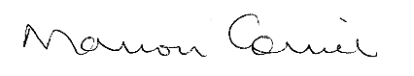 (Marion Cornick)
Approved by the Designated Safeguarding Lead: 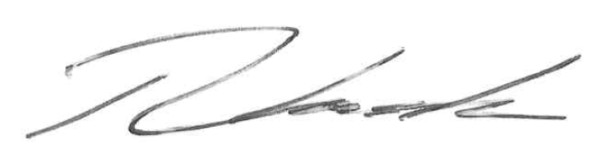 (Tim Clark)
Date: September 2020 Next Review Date: September 2021

Appendix 1 – Procedure for reporting a concern about a child

Children must feel safe and be safe. Safeguarding our children is everyone’s responsibility
If you see anything that concerns you, you must:
- Make sure the child is safe
- Immediately report your concern to Tim Clark, Vice-principal - Care & Designated Safeguarding Lead (DSL)
- In his absence, report to a DSL deputy: Kelly Simpson, Alison Beaven or Joanna Emerson or the duty manager on call.
- Complete the Safeguarding Concern form found on the Loddon Internet Hub

If your concern relates either the Principal or Vice-principal you must raise your concerns with:
Trustee responsible for Safeguarding, Joy Wake
Tel: 07747625773 or joy.wake@googlemail.com
Chair of trustees, Steve Fussey
Tel: 07887518010 or steve.fussey@gmail.com
Responsible Individual, Marion Cornick
Tel: 01256 354985 or m.cornick@loddonschool.co.uk
If you are unable to report to the individuals above or are not satisfied your concern has been adequately addressed, you should contact:
Hampshire Safeguarding Children’s Partnership directly
Tel: 0300 555 1384 Or, out of hours: 0300 555 1373
Appendix 2 – Types of Abuse

Definitions of abuse and neglect
Taken from Keeping Children Safe in Education 2020
Abuse: a form of maltreatment of a child. Somebody may abuse or neglect a child by inflicting harm or by failing to act to prevent harm. Children may be abused in a family or in an institutional or community setting by those known to them or, more rarely, by others. Abuse can take place wholly online, or technology may be used to facilitate offline abuse. Children may be abused by an adult or adults or by another child or children.
Physical abuse: a form of abuse which may involve hitting, shaking, throwing, poisoning, burning or scalding, drowning, suffocating or otherwise causing physical harm to a child. Physical harm may also be caused when a parent or carer fabricates the symptoms of, or deliberately induces, illness in a child.
Emotional abuse: the persistent emotional maltreatment of a child such as to cause severe and adverse effects on the child’s emotional development. It may involve conveying to a child that they are worthless or unloved, inadequate, or valued only insofar as they meet the needs of another person. It may include not giving the child opportunities to express their views, deliberately silencing them or ‘making fun’ of what they say or how they communicate. It may feature age or developmentally inappropriate expectations being imposed on children. These may include interactions that are beyond a child’s developmental capability as well as overprotection and limitation of exploration and learning, or preventing the child from participating in normal social interaction. It may involve seeing or hearing the ill-treatment of another. It may involve serious bullying (including cyberbullying), causing children frequently to feel frightened or in danger, or the exploitation or corruption of children. Some level of emotional abuse is involved in all types of maltreatment of a child, although it may occur alone.
Sexual abuse: involves forcing or enticing a child or young person to take part in sexual activities, not necessarily involving a high level of violence, whether or not the child is aware of what is happening. The activities may involve physical contact, including assault by penetration (for example rape or oral sex) or non-penetrative acts such as masturbation, kissing, rubbing and touching outside of clothing. They may also include non-contact activities, such as involving children in looking at, or in the production of, sexual images, watching sexual activities, encouraging children to behave in sexually inappropriate ways, or grooming a child in preparation for abuse. Sexual abuse can take place online, and technology can be used to facilitate offline abuse. Sexual abuse is not solely perpetrated by adult males. Women can also commit acts of sexual abuse, as can other children. The sexual abuse of children by other children is a specific safeguarding issue in education (see paragraph 29).
Neglect: the persistent failure to meet a child’s basic physical and/or psychological needs, likely to result in the serious impairment of the child’s health or development. Neglect may occur during pregnancy, for example, as a result of maternal substance abuse. Once a child is born, neglect may involve a parent or carer failing to: provide adequate food, clothing and shelter (including exclusion from home or abandonment); protect a child from physical and emotional harm or danger; ensure adequate supervision (including the use of inadequate care-givers); or ensure access to appropriate medical care or treatment. It may also include neglect of, or unresponsiveness to, a child’s basic emotional needs.
Staff working with children must be aware of the following types of abuse and safeguarding issues and the action required by them in event of a related concern
Children and the court system
Children missing from education
Children with family members in prison
Child Criminal Exploitation (CCE)
Child Sexual Exploitation (CSE)
County lines
Domestic abuse
Homelessness
So-called ‘honour-based’ abuse (including FGM and Forced Marriage)
Female Genital Mutilation (FGM)
Forced marriage
Preventing radicalisation
The Prevent duty
Channel
Peer on peer/child on child abuse
Sexual violence and sexual harassment between children in schools and colleges
Upskirting

These are detailed in Annex A of KCSIE. Use this link to read the most up to date copy of Part One & Annex A of Keeping Children Safe in Education.
Self-injury
Self-injurious behavior (SIB) involves the occurrence of behavior that could result in physical injury to one's own body. This type of self-injury can be a way to get needs met or cope with pain, anxiety, and frustration; it can be used to gain attention, tangibles or to meet internal sensory needs.
Staff at The Loddon School are also made aware of KCSIE Annex A content through safeguarding refresher training. Staff are to understand how these events occurring in either a child’s or staff’s life or background will influence the individual. Staff are given details of what each type of abuse might include and how they might recognize the symptoms. More importantly, staff at The Loddon School are given training on preventing any type of abuse.

Appendix 3 - Flow chart for child protection procedure

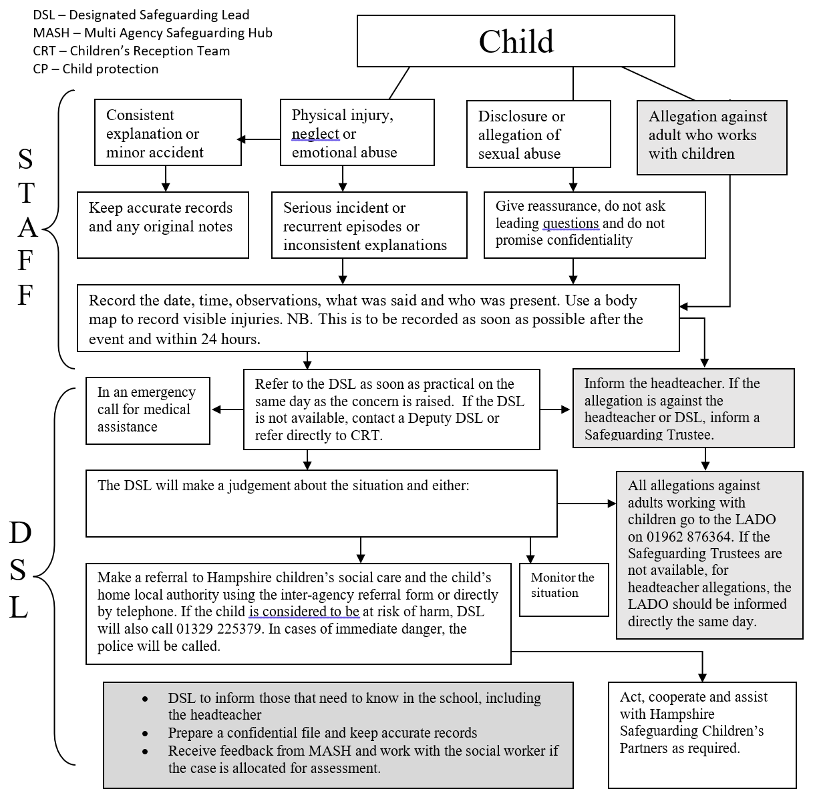
* In the cases of known FGM, the member of staff who was made aware will also make contact with the police.

